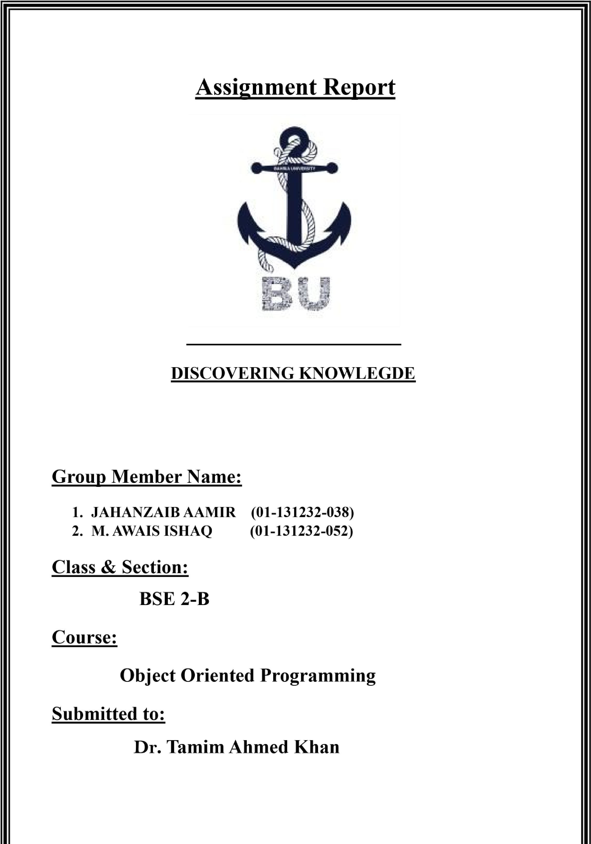

Tool Used:

* GitHub Web
* Microsoft Visual Studio 2022
* ChatGPT
* SQL Server

GiTHUb link:

https://github.com/AwaisIshaq7/OOP-Assignment-2.git

screensHoTs:

The following are some screenshots of the (project) Assignment 3:

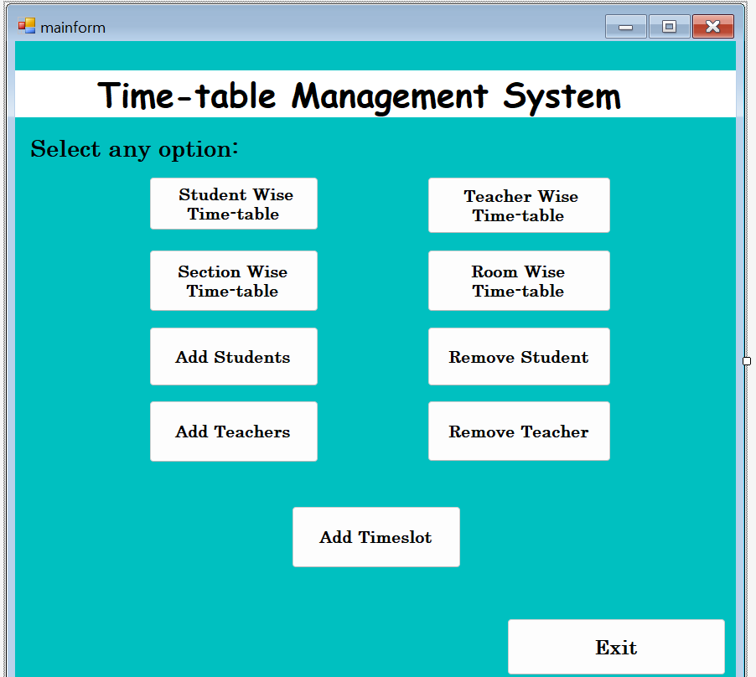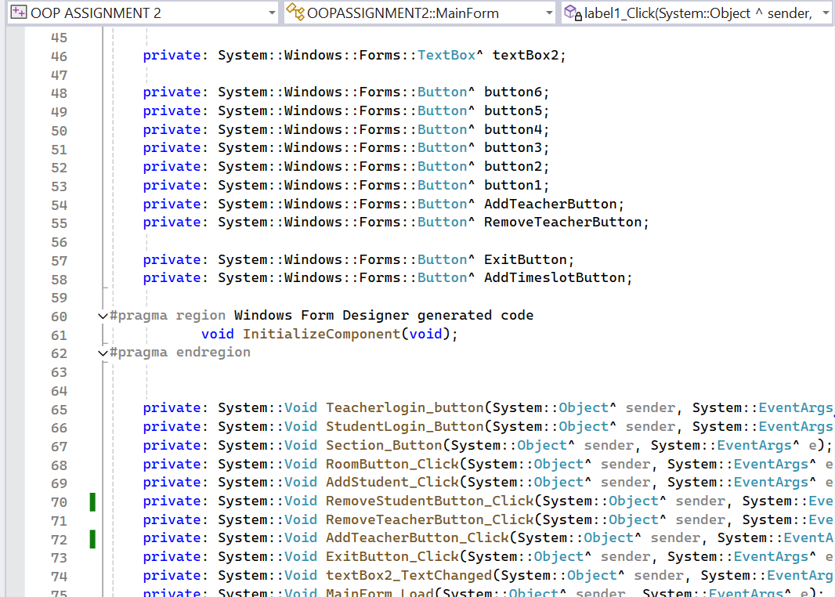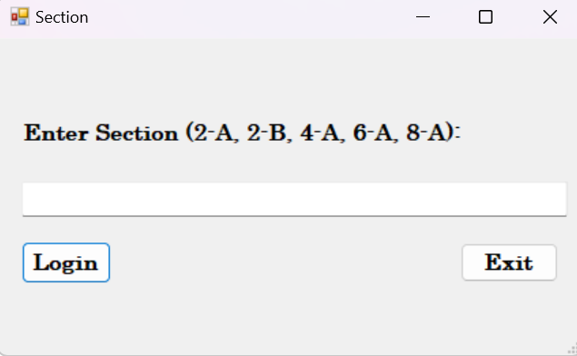

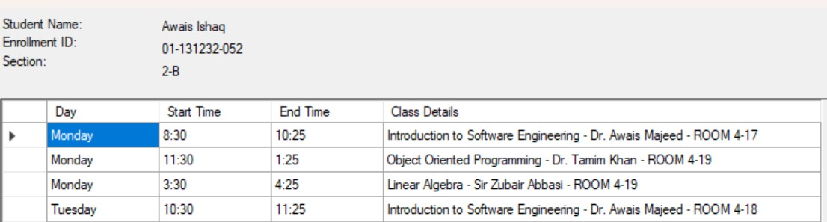

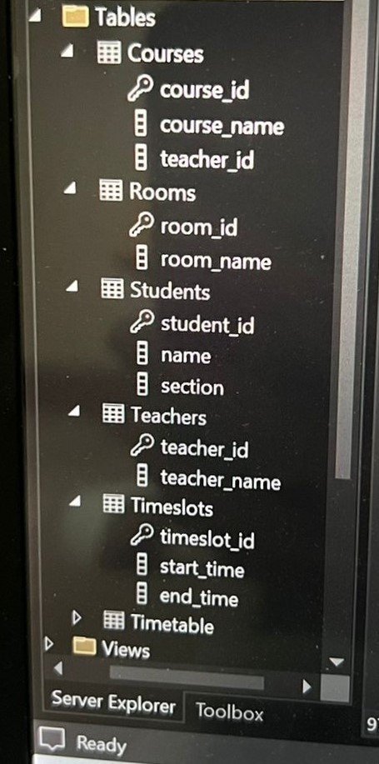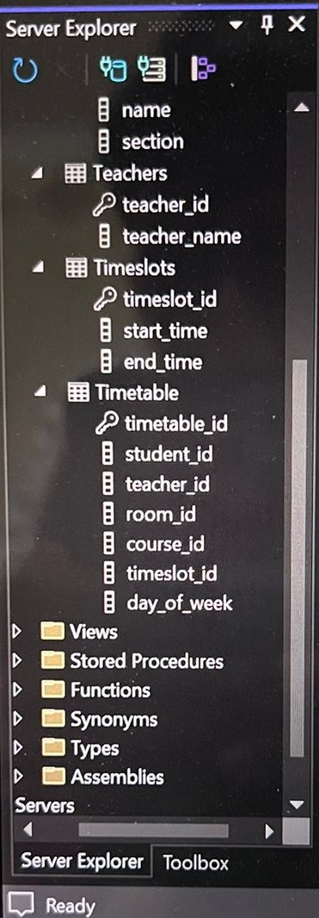

**Conclusion:** In this lab we were given the tasks mentioned in the instructions (assignment 3) file and used the basis from the previous 2 assignments to perform this new task of assignment 3 by making some changes in the code and using database in SQL server instead of using file handling and also performed other tasks(activities) related to the Assignment.